TIPPED & TUCKED MONSTER SCRAMBLE
BENEFITING THE MIDDLETOWN HIGH SCHOOL GOLF TEAM
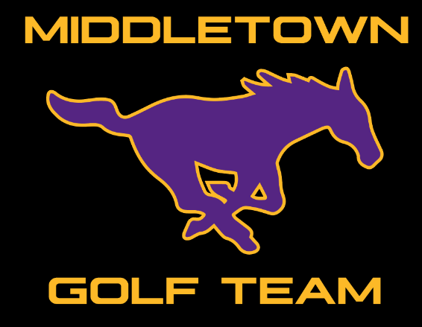
When: Saturday March 26th, 222
8:30 AM shotgun start
Cost: $25 per player for pre-paid members
$60 per player for non-members
*Entry Fee includes green fee, cart and prizes
On course events include: Closest to the pin contests, long drive, 50/50 putting contest. Please help our kids out by donating to this fun event. All proceeds go to our MHS golf team.
Player 1 _________________________
Player 2 _________________________
Player 3 _________________________
Player 4 _________________________
Please turn in your team to the Pro-Shop or email your entry to:
golfdir@hvla.com
Pro-Shop Phone: 707-987-3035
HELP SUPPORT AND BUILD OUR GOLF PROGRAM
#GoMustangs

